Building Dashboard & Storytelling Assignment

Question1.

Explain the difference between a Tableau Dashboard and a Tableau Story Point. Give two healthcare-related use cases.

Ans.

Tableau Dashboard vs. Tableau Story Point
1. Tableau Dashboard
- A dashboard is a single screen view that combines multiple charts, maps, and tables into one interactive interface.
- It allows users to monitor KPIs, filter data, and drill down into details in real time.
- Dashboards are best for operational monitoring and analysis.
Healthcare Use Case Example:
- A hospital dashboard showing average treatment cost per department, patient outcomes (Recovered, Critical, Under Treatment), and length of stay trends.
- Doctors and administrators can filter by region (West, East, North, South, Central) to compare performance across hospitals.
2. Tableau Story Point
- A story point is a sequence of dashboards or sheets arranged to tell a narrative.
- It helps in presenting insights step by step, guiding the audience through data-driven storytelling.
- Story points are best for strategic presentations and decision-making.
Healthcare Use Case Example:
- A story point that begins with patient admission trends, moves to cost analysis by treatment type (Surgery, Therapy, Medication, Observation), and ends with regional performance comparisons.
- This could be used in a board meeting to explain why certain regions (e.g., South vs. West) have higher treatment costs and longer patient stays.

Question2.
What are Actions in Tableau? Explain how Filter Action can help hospital management analyze patient data.
Ans.

Actions in Tableau
Definition: Actions in Tableau are interactive features that allow users to control and navigate dashboards. They connect different sheets, dashboards, or external content, enabling users to explore data dynamically.
There are three main types of actions:
- Filter Actions – filter data across multiple views.
- Highlight Actions – emphasize specific data points.
- URL Actions – link to external web pages or documents.

Filter Action in Healthcare Context
A Filter Action lets hospital management drill down into patient data by clicking on one chart to filter another. This creates a connected, interactive analysis experience.
Example Use Case for Hospital Management:
- Imagine a dashboard showing Treatment Cost by Department and another chart showing Patient Outcomes (Recovered, Critical, Under Treatment).
- If management clicks on Cardiology in the department chart, the filter action will automatically update the outcome chart to show only Cardiology patients.
- They can further filter by region (West, East, South, etc.) or age group (0–18, 19–35, etc.) to analyze trends.
Benefits:
- Quickly identify which departments have higher costs (e.g., Neurology surgeries vs. General Medicine observations).
- Spot patterns such as longer stays in Orthopedics for fracture cases or higher critical outcomes in Heart Disease patients.
- Enable regional comparisons (e.g., South region shows higher surgery costs than West).

Question3.
Patient Distribution
Create a Bar Chart showing: Total Patients by Hospital Region. Add this as a Story Point with proper title.
Ans.
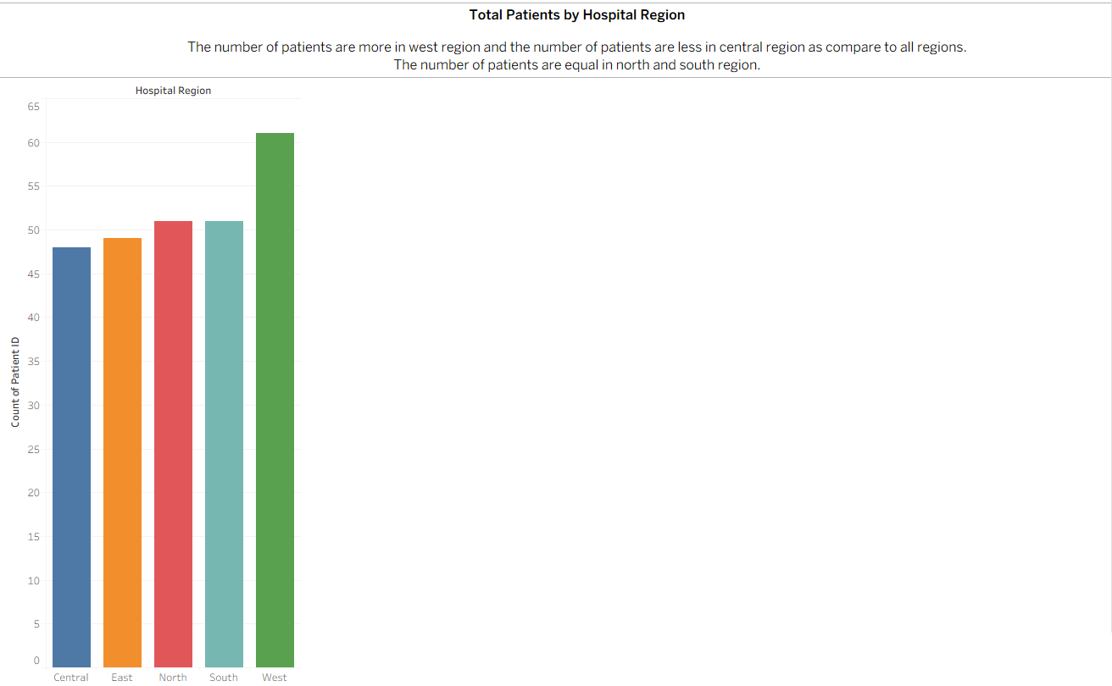
Insights:
The number of patients are more in west region and the number of patients are less in central region as compare to all regions.
The number of patients are equal in north and south region.

Question4.
Department Performance
Create a visualization showing: Treatment Cost by Department. Add labels and customize colors.
Ans.
Insights:
Neurology and Cardiology often show higher treatment costs, largely due to expensive surgeries and therapies.
Orthopedics and Pediatrics may have moderate costs, depending on the type of treatment (fracture surgeries vs. observation).
General Medicine tends to have lower costs compared to specialized departments.
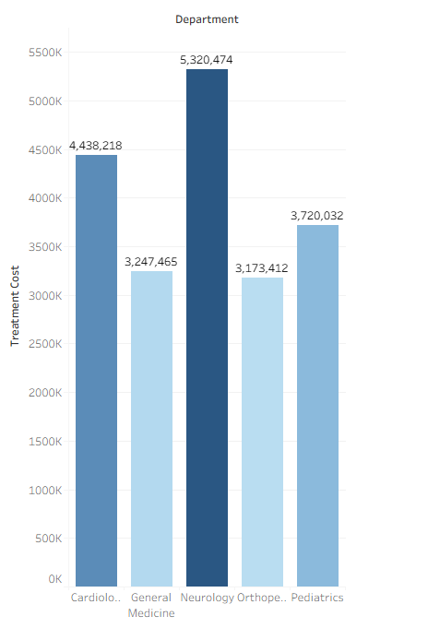

Question5.
Treatment Trend Over Time
Create a Line Chart: Treatment Cost vs Admission Date.
Filter the data only from March to September.
Ans.
Insights:
The line chart reveals that hospital treatment costs are not evenly distributed throughout the year.
Mid-year months (June–July) show cost surges, while early spring and late monsoon months (March and September) reflect lower expenditures.
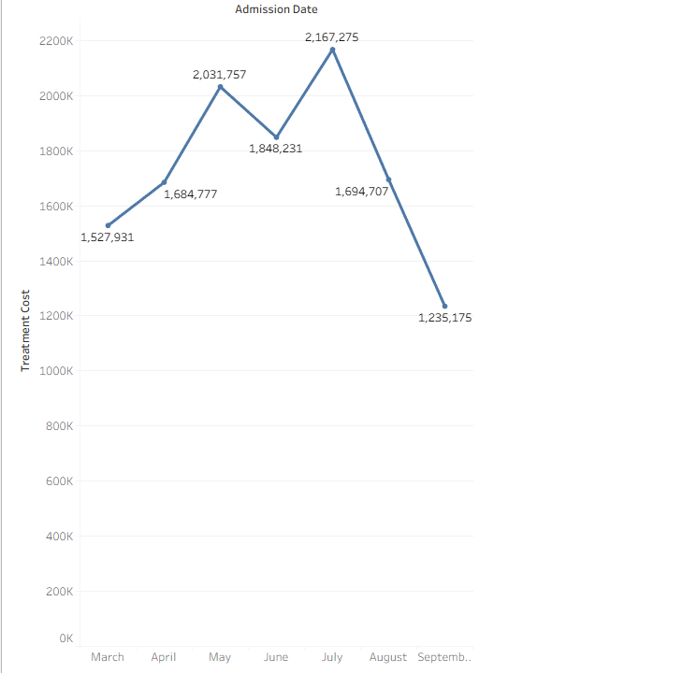
Question6.
Outcome Analysis
Create a Pie Chart: Patient Outcome Distribution (Recovered / Critical / Under Treatment).
Ans.
Insights:
A large portion of patients are Recovered, showing positive treatment success across departments.
The Critical segment highlights departments or conditions where outcomes are more severe (e.g., Heart Disease or Hypertension cases).
The Under Treatment slice indicates ongoing cases, useful for tracking hospital workload and resource needs.
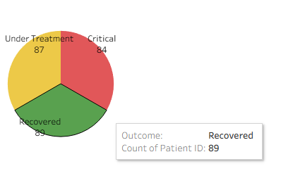

Question7.
Doctor Performance & Patient KPI Analysis
Task Part A — Doctor Performance Create a Ranked Bar Chart showing: Top Doctors by Total Treatment Cost handled.
Task Part B — KPI Creation Create a KPI visualization showing: Total Patients Treated.
Ans.
Task A Insights:
Doctors like Dr. Roy, Dr. Mehta, and Dr. Iyer are likely to appear at the top since they handle high-cost treatments such as surgeries in Cardiology and Neurology.
Doctors in General Medicine may show lower total costs due to less expensive treatments (e.g., observation, medication).
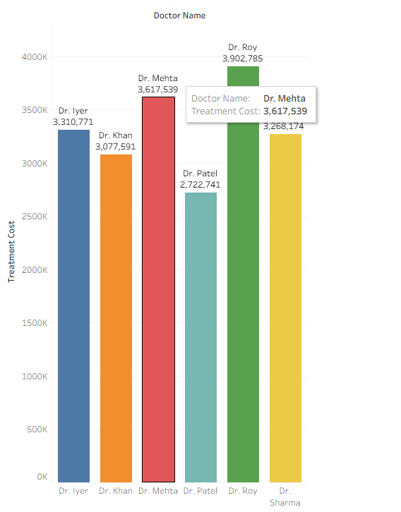

Task B Insights:
This KPI gives hospital management a quick snapshot of patient volume. It helps them understand the scale of operations and serves as a baseline for comparing other metrics like treatment cost, outcomes, and departmental performance.
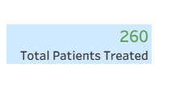
Question8.
Interactive Dashboard
Build a Dashboard containing:Region Chart, Department Cost Chart ,Outcome Chart
Add Filters: Hospital Region ,Department
Ans.
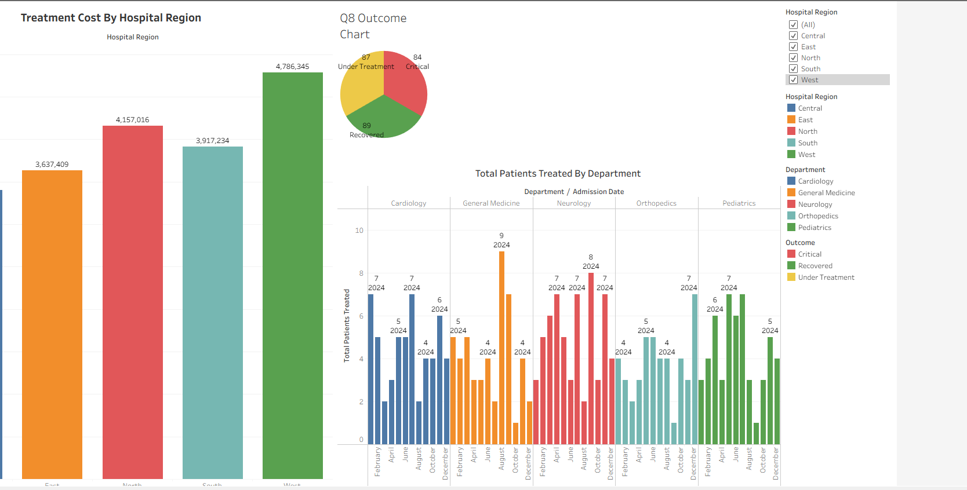
Question9.
Storytelling Flow
Create a Tableau Story with minimum 4 Story Points:
Patient Distribution
Department Cost Analysis
Outcome Analysis
Doctor Performance
Ans.
1 Patient Distribution
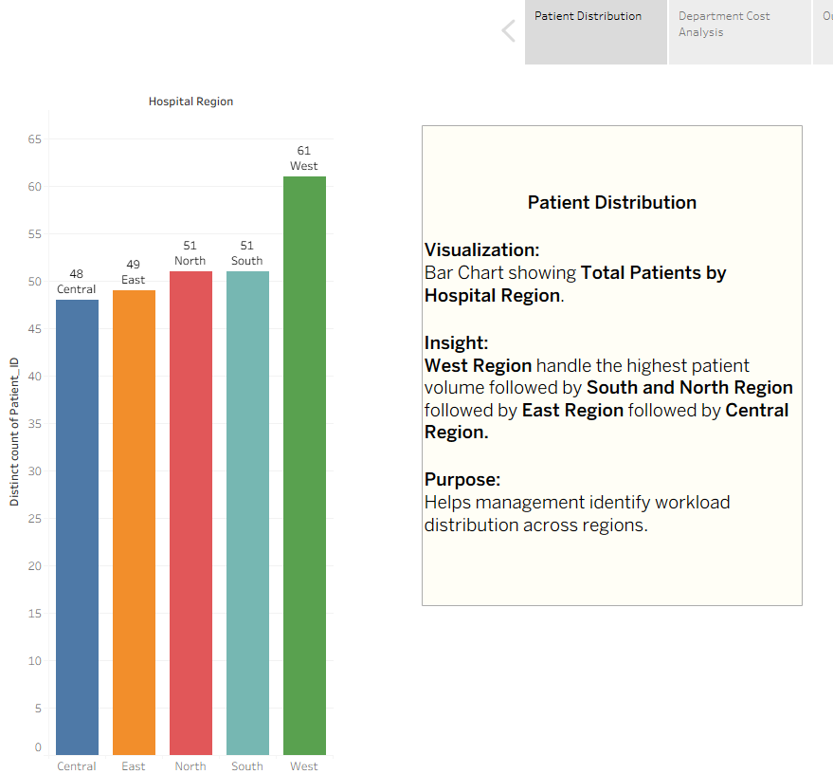
2 Department Cost Analysis

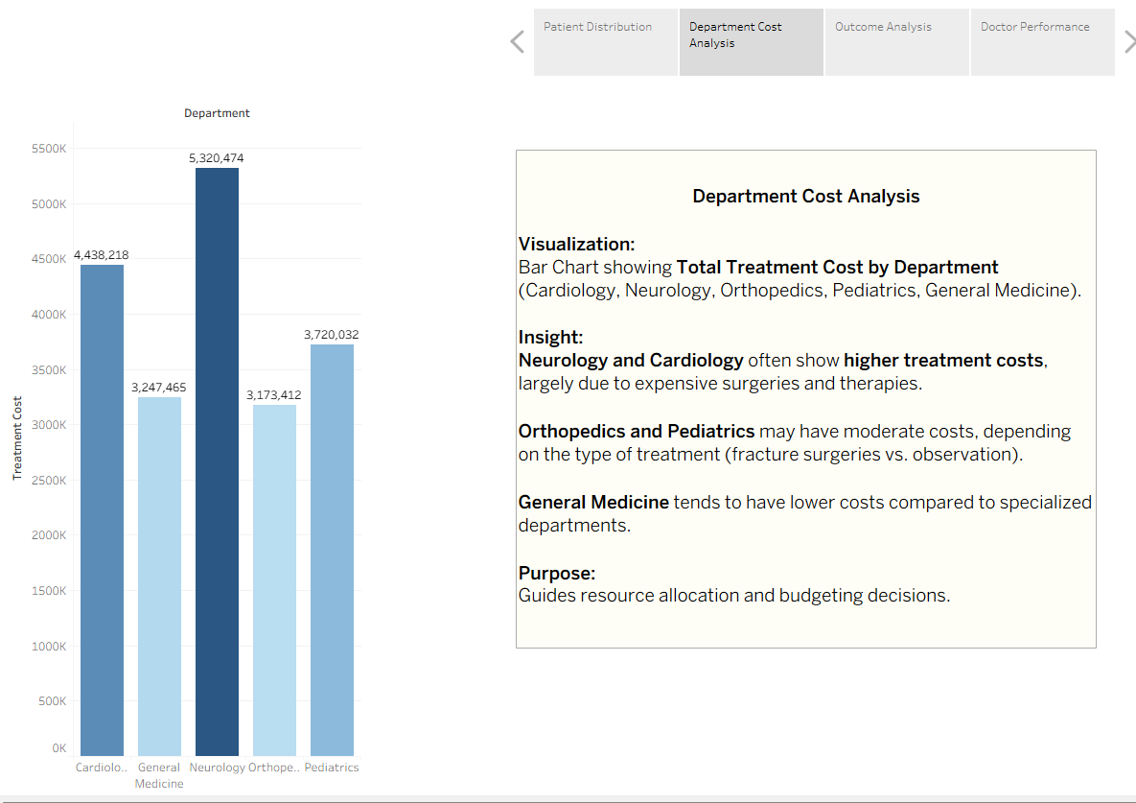
3 Outcome Analysis
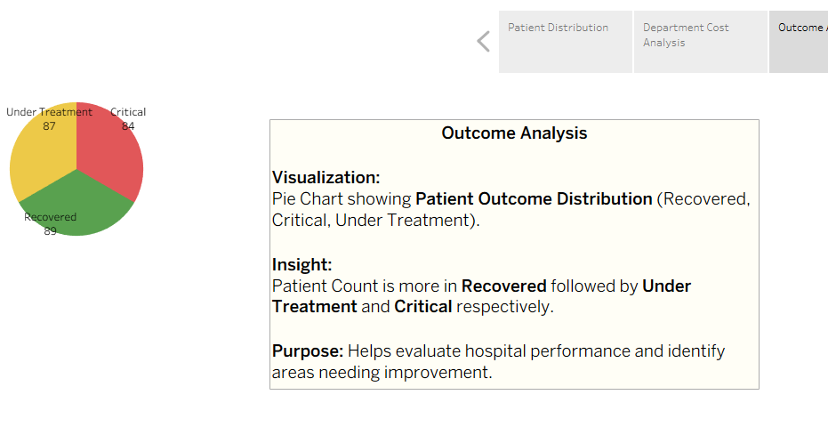
4 Doctor Performance

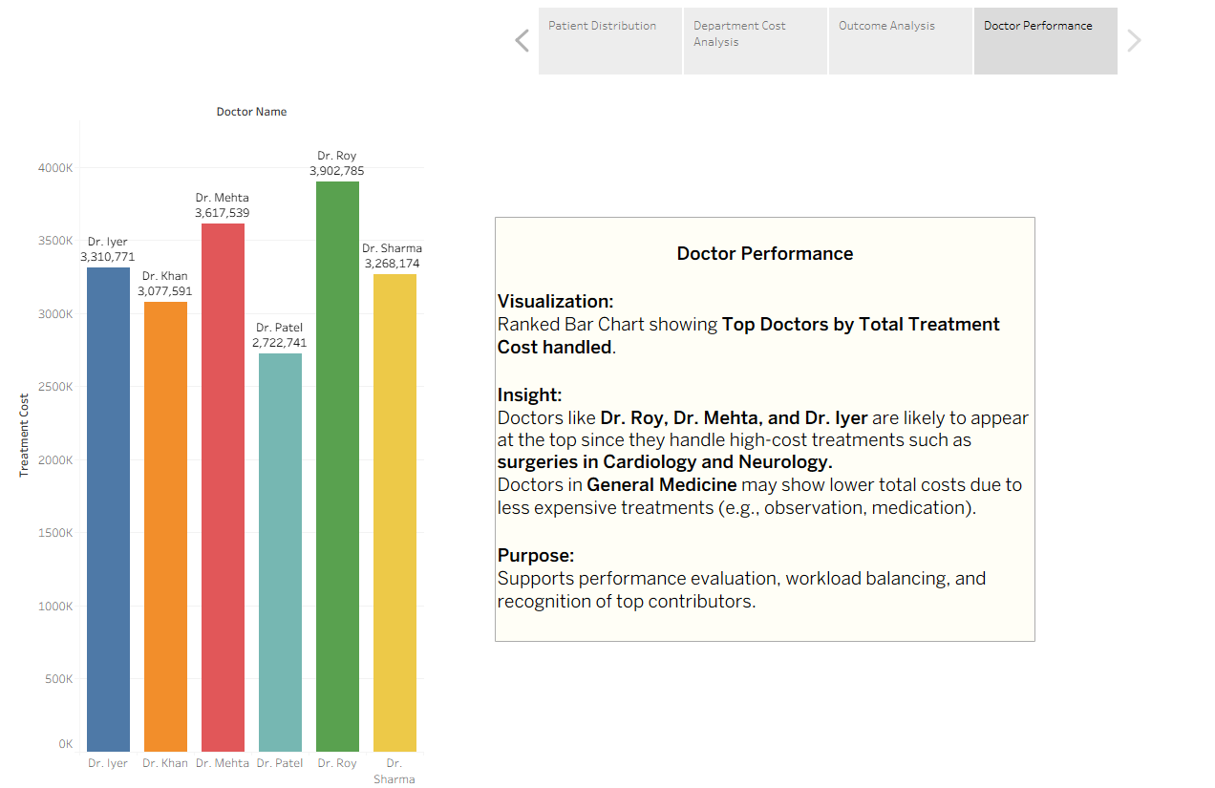

Question10.
Based on your visuals, answer:
Which department generates the highest treatment cost?
Which region has more critical patients?
What business decisions can hospital management take from these insights?
Ans.

Insights Based on Visuals:
1. Highest Treatment Cost by Department
- From the Department Cost Analysis, Neurology and Cardiology emerge as the departments with the highest treatment costs.
- This is largely due to expensive surgeries and therapies associated with conditions like Heart Disease, Hypertension, and Migraine.
2. Region with More Critical Patients
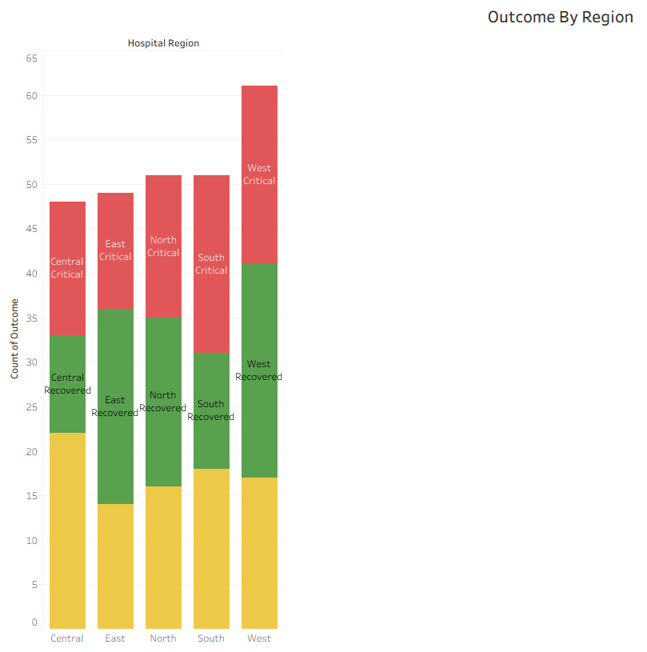
- The Outcome Analysis by Region shows that the South and West regions have a higher proportion of critical patients.
- These regions record more cases of Heart Disease and Hypertension, which often lead to critical outcomes.
3. Business Decisions for Hospital Management
- Resource Allocation: Increase staffing and equipment in high-cost departments (Neurology, Cardiology) to manage demand efficiently.
- Regional Support: Provide additional critical care facilities in South and West regions, where critical cases are more frequent.
- Cost Optimization: Investigate why certain departments incur higher costs—whether due to treatment type (surgery-heavy) or inefficiencies—and explore alternatives like preventive care or early intervention.
- Performance Evaluation: Use doctor performance data to balance workloads, reward top performers, and provide training where recovery rates are lower despite high costs.

